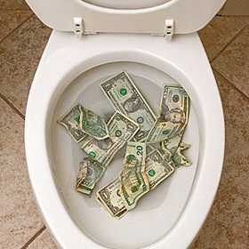

Running toilets, dripping faucets or hoses can have different speeds at which they cost you money. A slow leak can waste 30 gallons a day while keeping you oblivious to the problem. 30 gallons a day is 900 gallons a month with a minimum bill of $30.80 plus your normal usage. A medium leak, on the other hand, is more noticeable and will go through roughly 250 gallons a day which is about 7,500 gallons of water per month a minimum charge of $59.12 plus usage. Let’s think about how much water just 1 gallon a minute may use. There are 1440 minutes in a day. If you use an average of 30 days and multiple that by 1440 minutes to get a total by month that is 43, 200 gallons which is a bill of around $289.07 plus usage. The worst case is a large leak, where your toilet or leak uses a constant flow of water, spending up to 4,000 gallons and adding a potential $30.00 per day to your bill. That is $871.87 plus the usage.

